
WORKSHOP REPORT
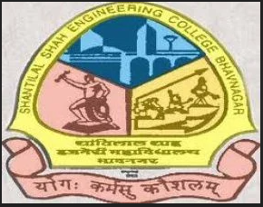

A workshop on 'Mind to Market' was conducted under SSIP 2.0 at Shantilal Shah Engineering College, Bhavnagar on 5th January 2026. The session was delivered by Prof. N. P. Soni. The workshop focused on transforming innovative ideas into practical market-ready solutions, encouraging students to develop entrepreneurial thinking and understand the process of innovation, startup development, and commercialization.
A total of 128 students actively participated in the event. The workshop created an engaging environment where students interacted with the speaker, shared innovative concepts, and learned about opportunities available under the SSIP initiative.
Event Details
Particular | Details
Event Name | Idea to entreprenureship
Organized Under | SSIP 2.0
Venue | Shantilal Shah Engineering College, Bhavnagar
Date | 05 January 2026
Speaker | Prof. N. P. Soni
Total Participation | 128 Students

Event Photographs
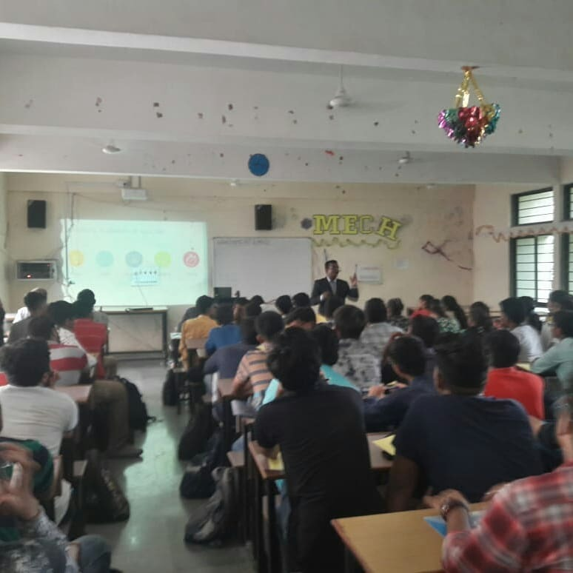
Workshop session in progress at Shantilal Shah Engineering College.
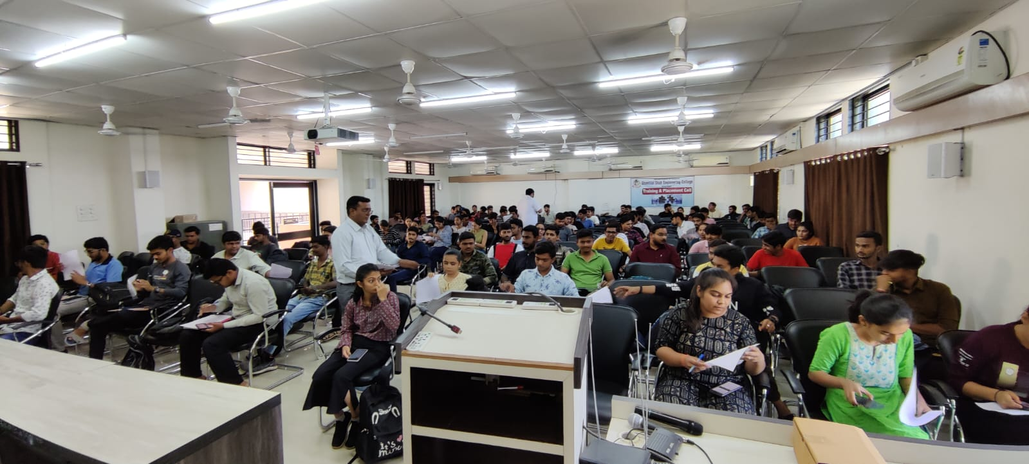
Participant attending the workshop.

Attendance Sheet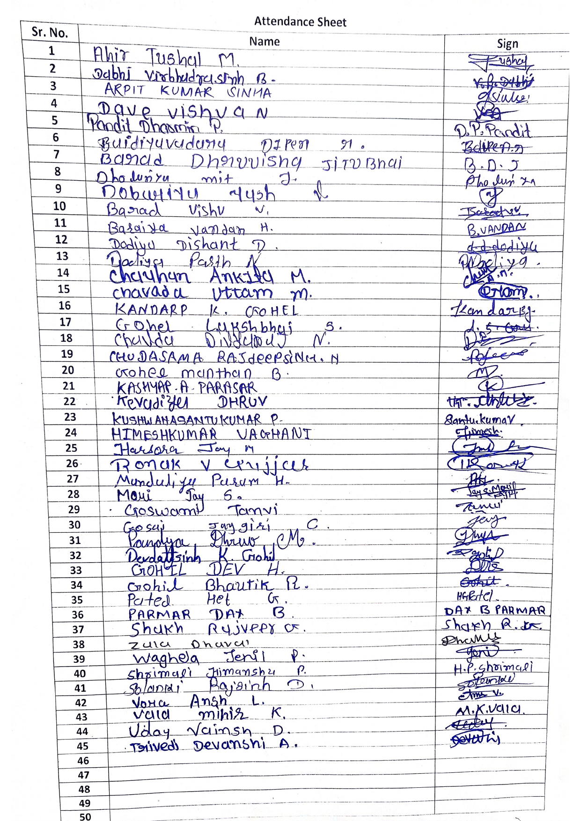
Attendance sheet submitted for the event.
The workshop successfully motivated students towards innovation and entrepreneurship, supporting the vision of SSIP 2.0 to nurture young innovators and future startup leaders.

